***CLYBOURN SPORTS CONSULTING COMPANY***

**Phase I**

The basic business requirement of any company to run their business are clients, proper system functionalities, services provided by the company and business work force etc. to provide best possible services to their clients as well as earn profit to reach business heights.

The relationship is the main agenda where a company has to maintain between them and their clients, employees and other factors which are associated with the company.

**ERD:**

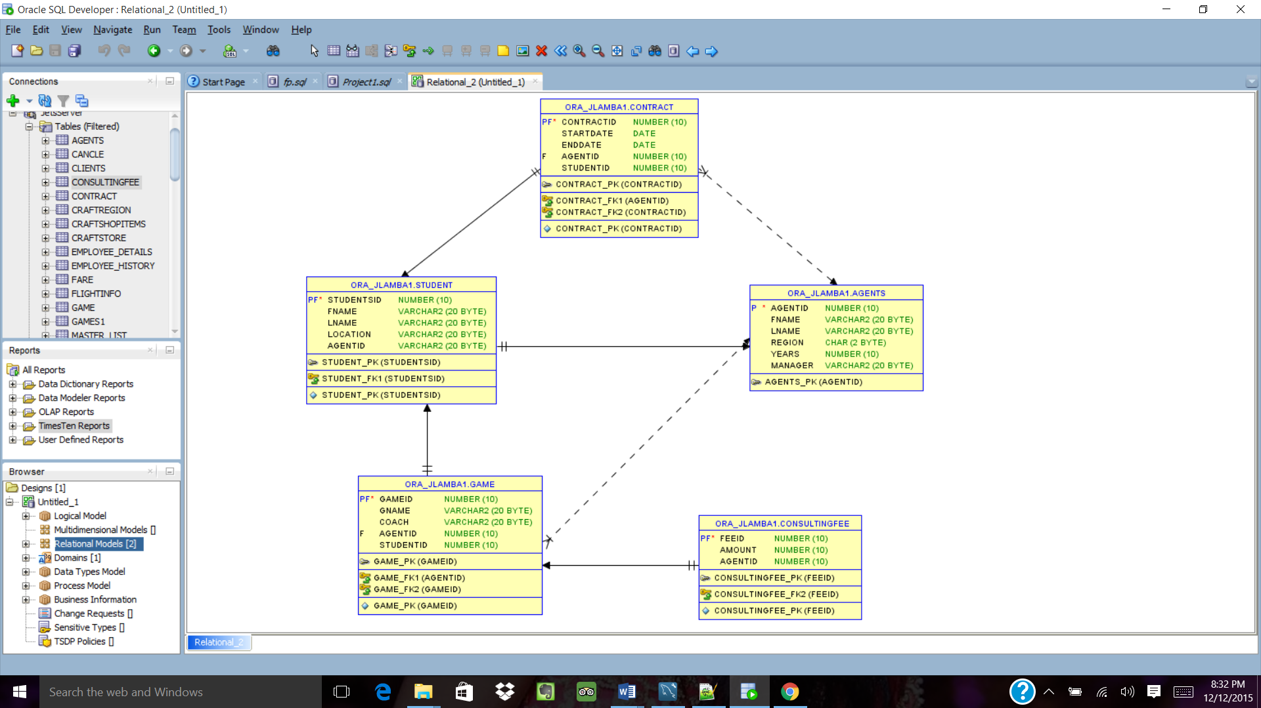

**Phase II**

**Column:**

**Agent**

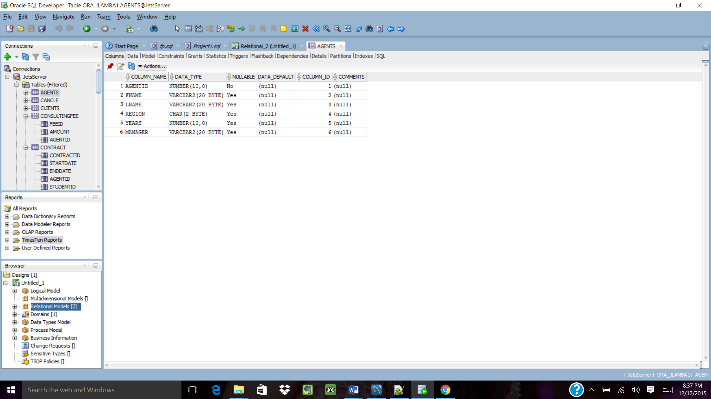

**Student**

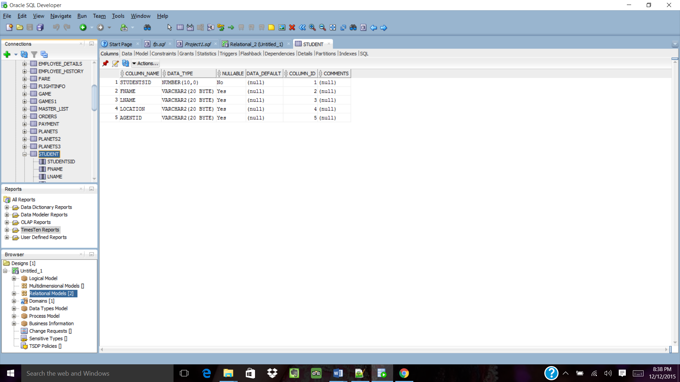

**Game**

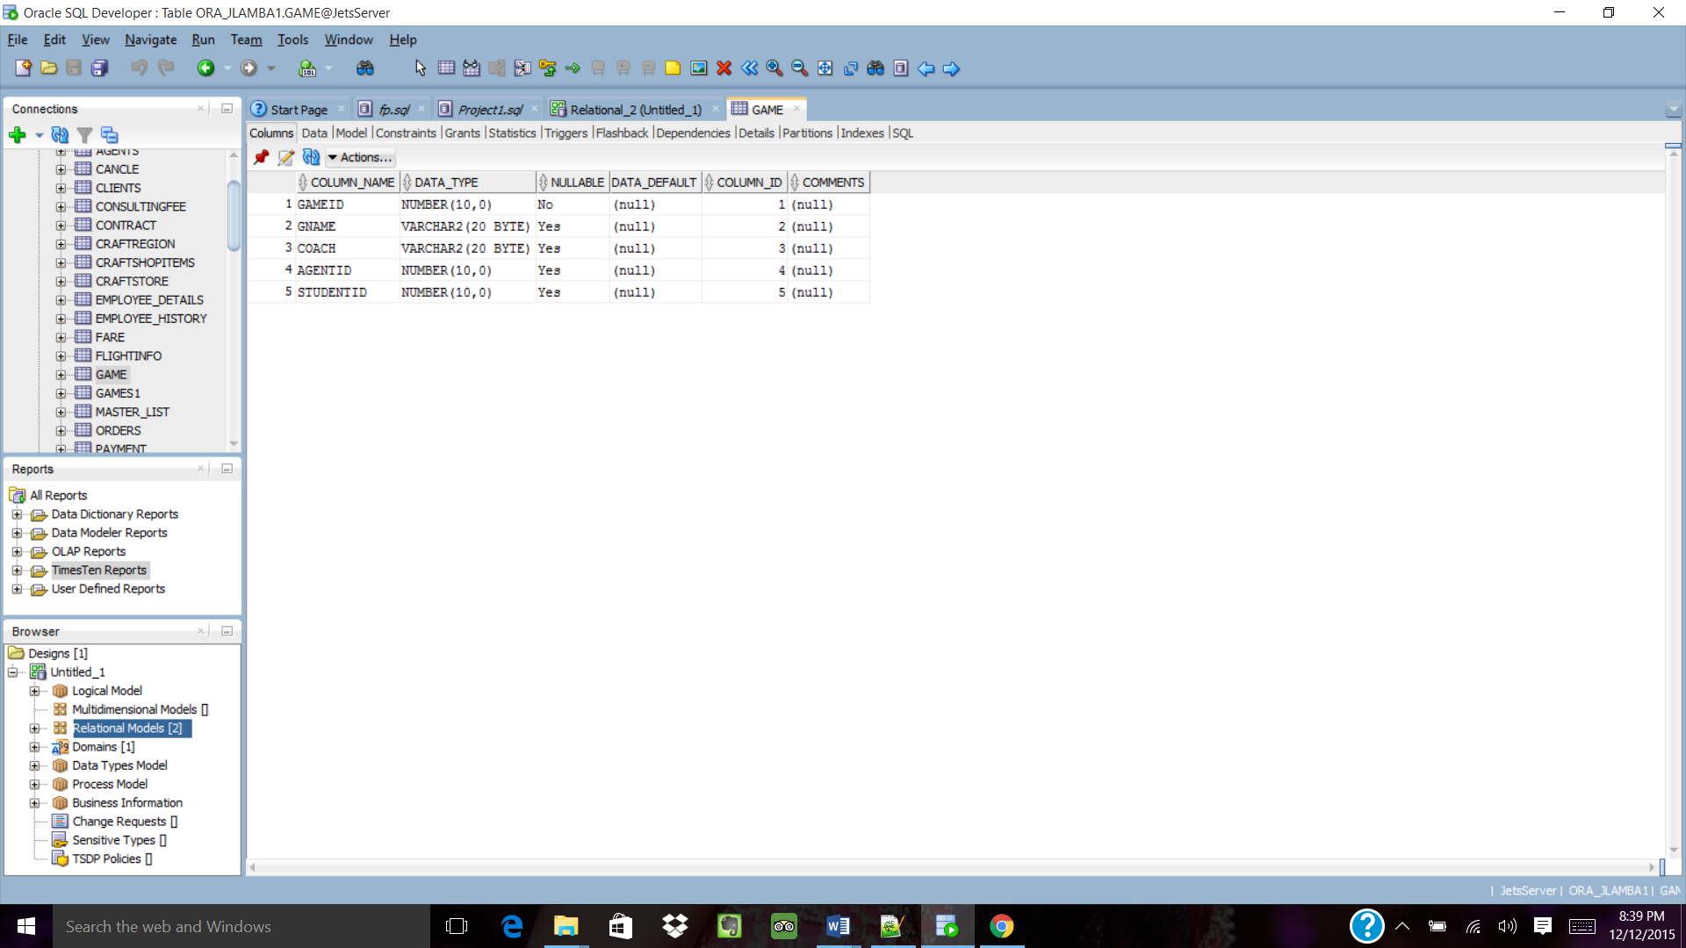

**Contract**

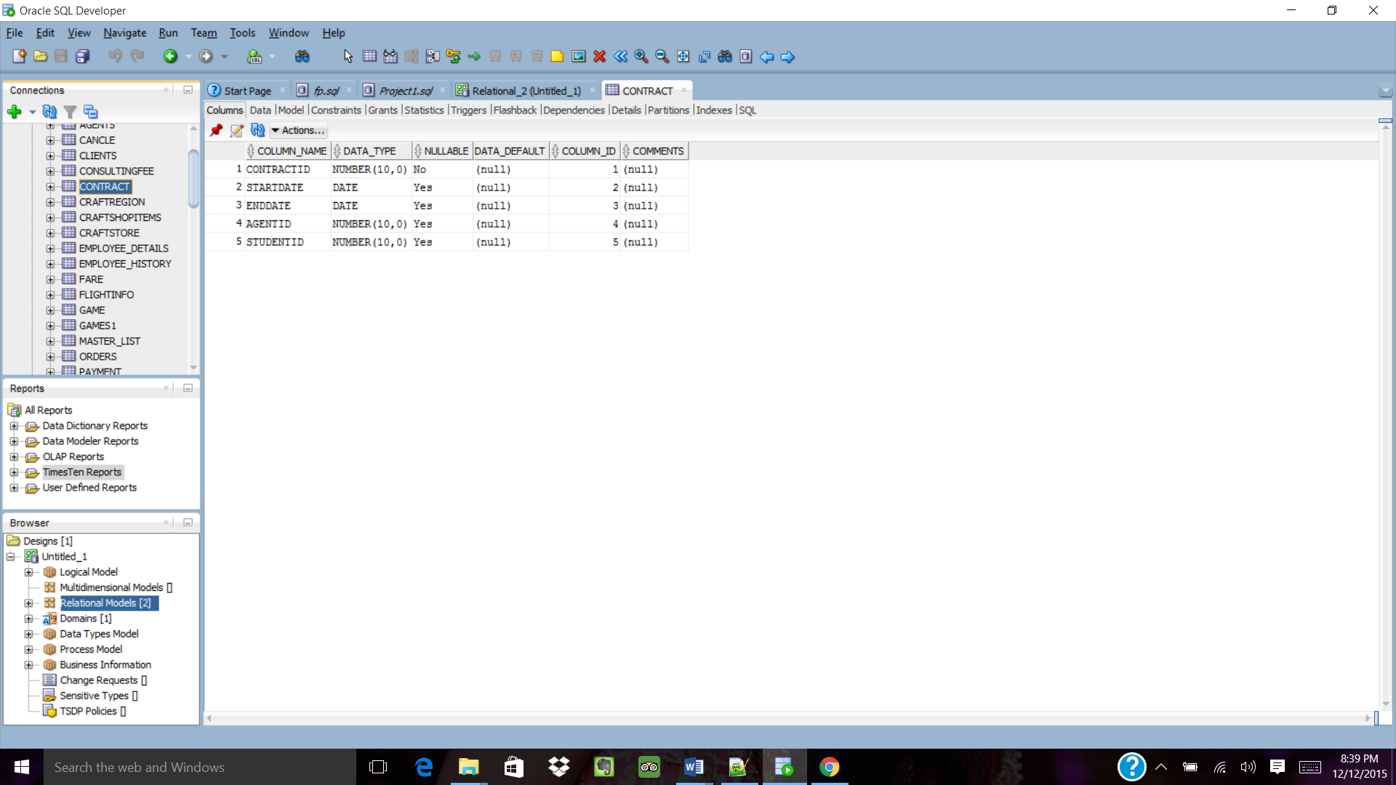

**Consultingfee**

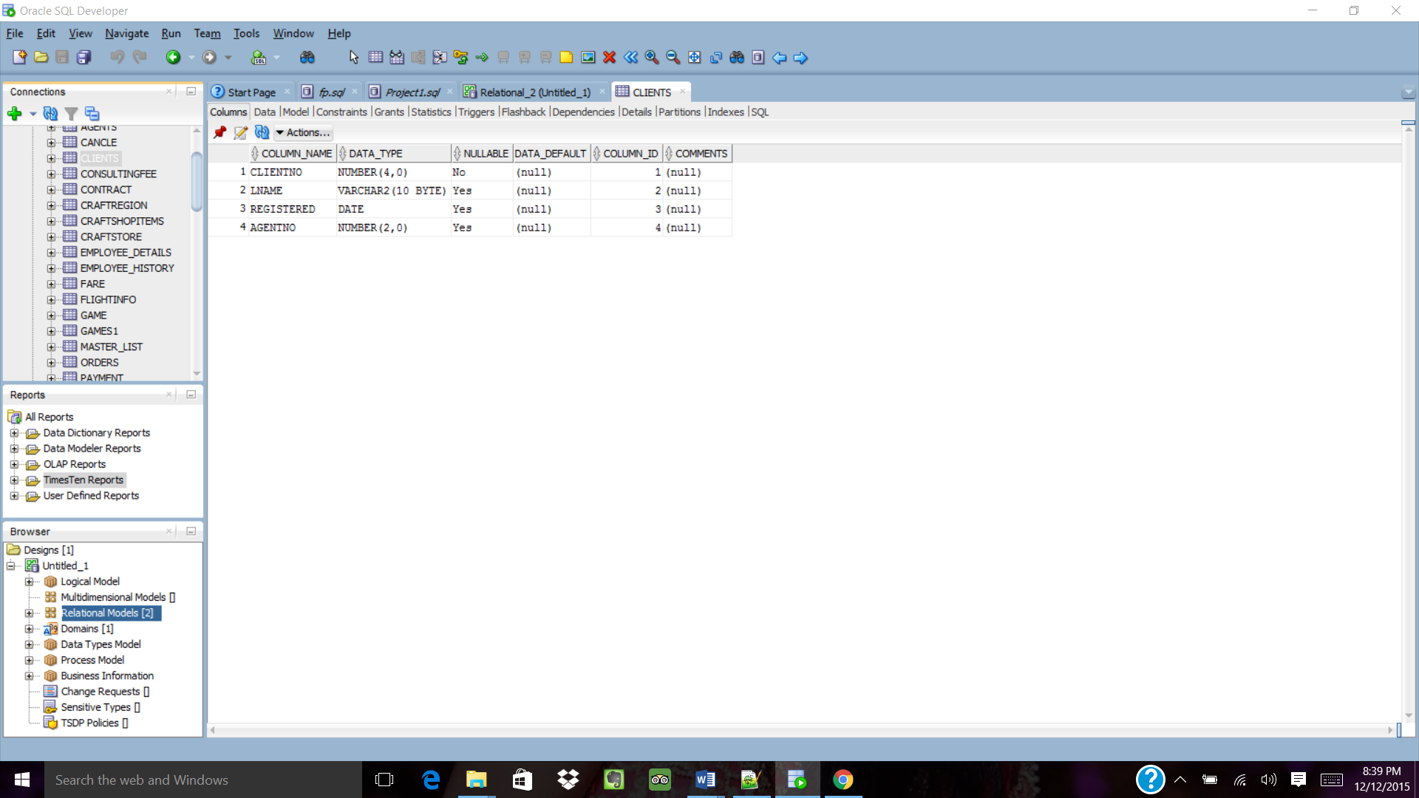

**Phase III**

**Data:**

**Agent table:**

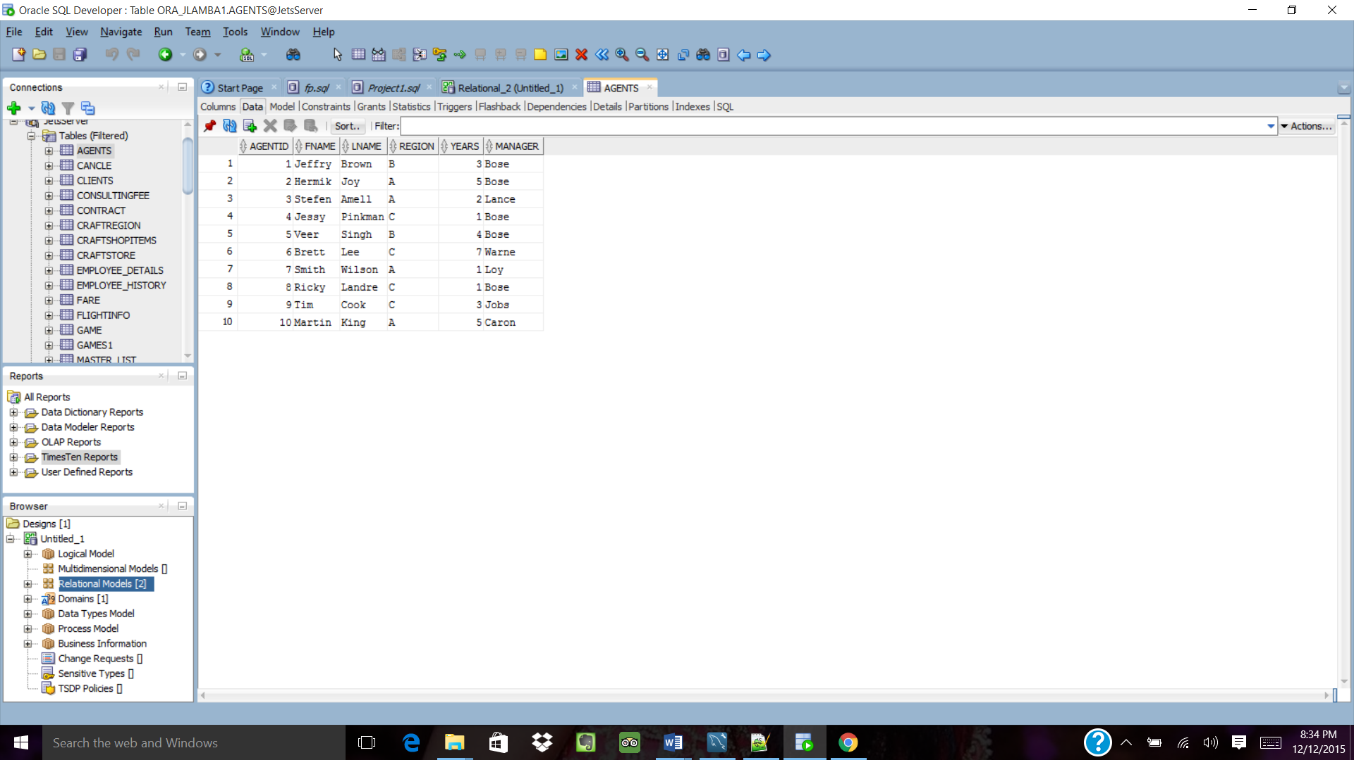

**Student Table:**

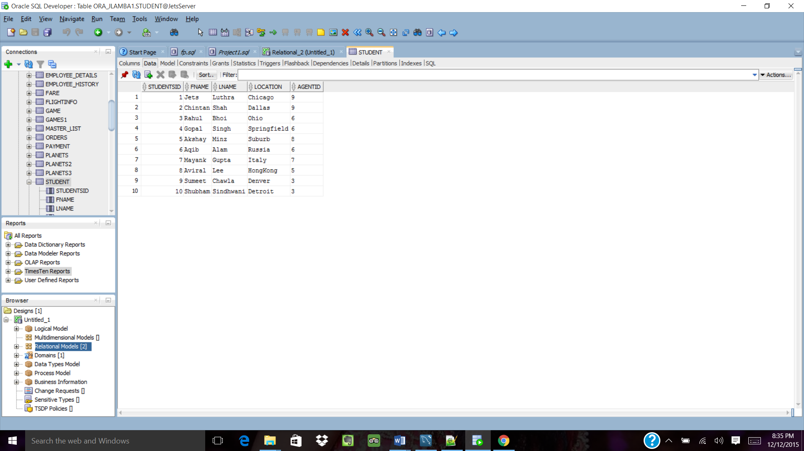

**Game Table:**

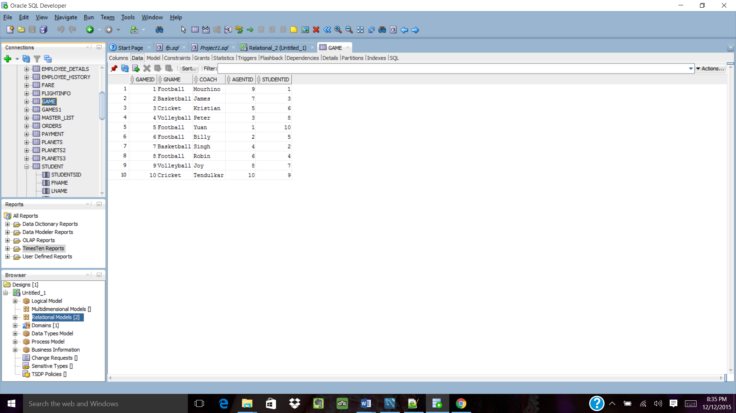

**Contract Table:**

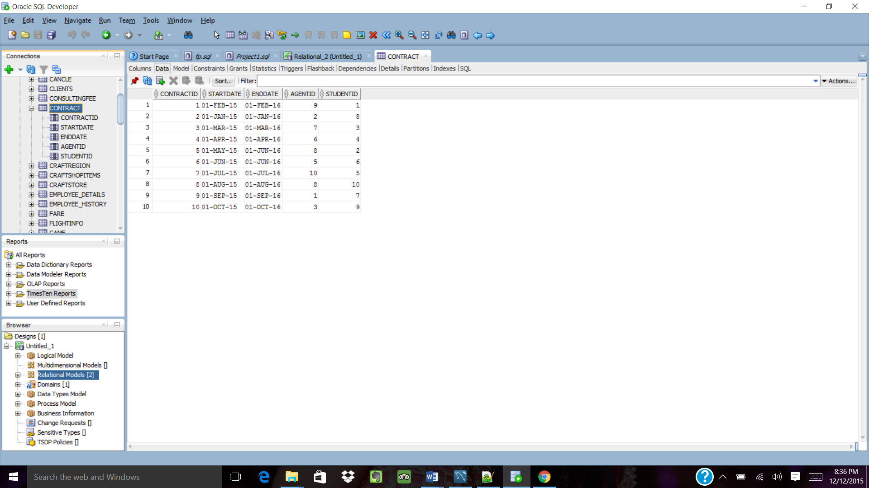

**ConsultingFee Table:**

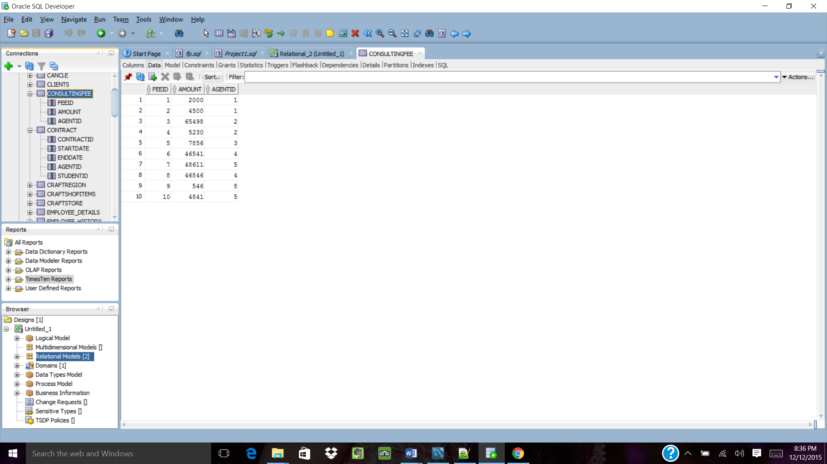

**Queries:**

**1.**

select Region from agents

union

select location from students;

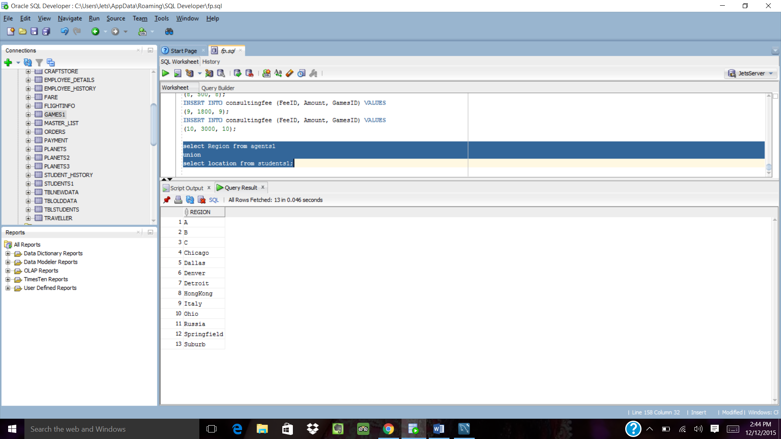

**2.**

select Region from agents

union all

select location from students;

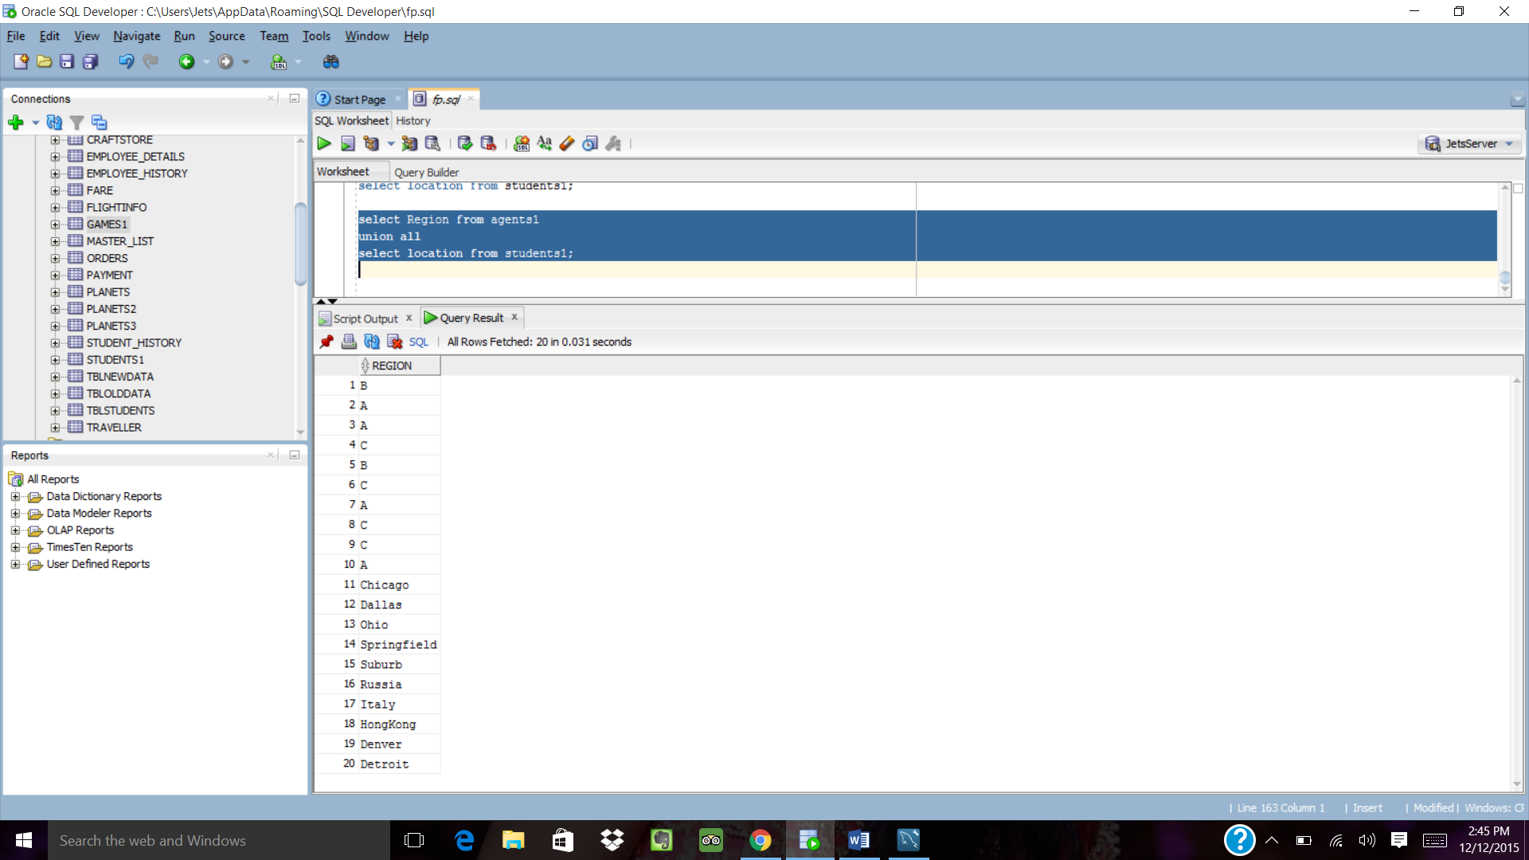

**3.**

Select LName from agents

Intersect

Select LName from students;

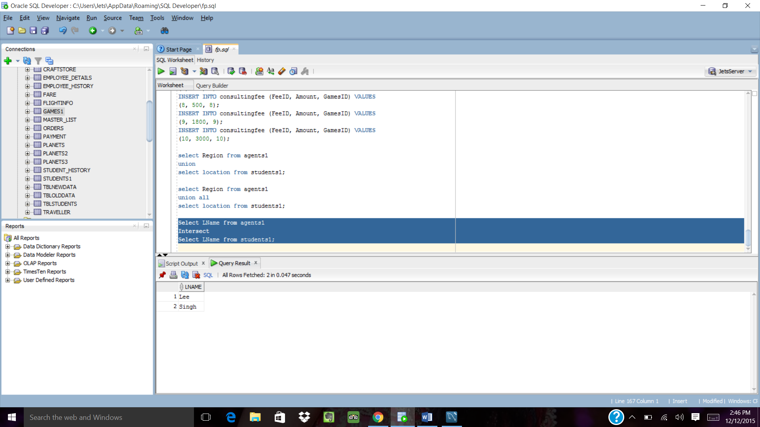

**4.**

select agentID,count(agentID) as "no_of_students_consulting"

from student

group by agentID

having count(agentid)>2;

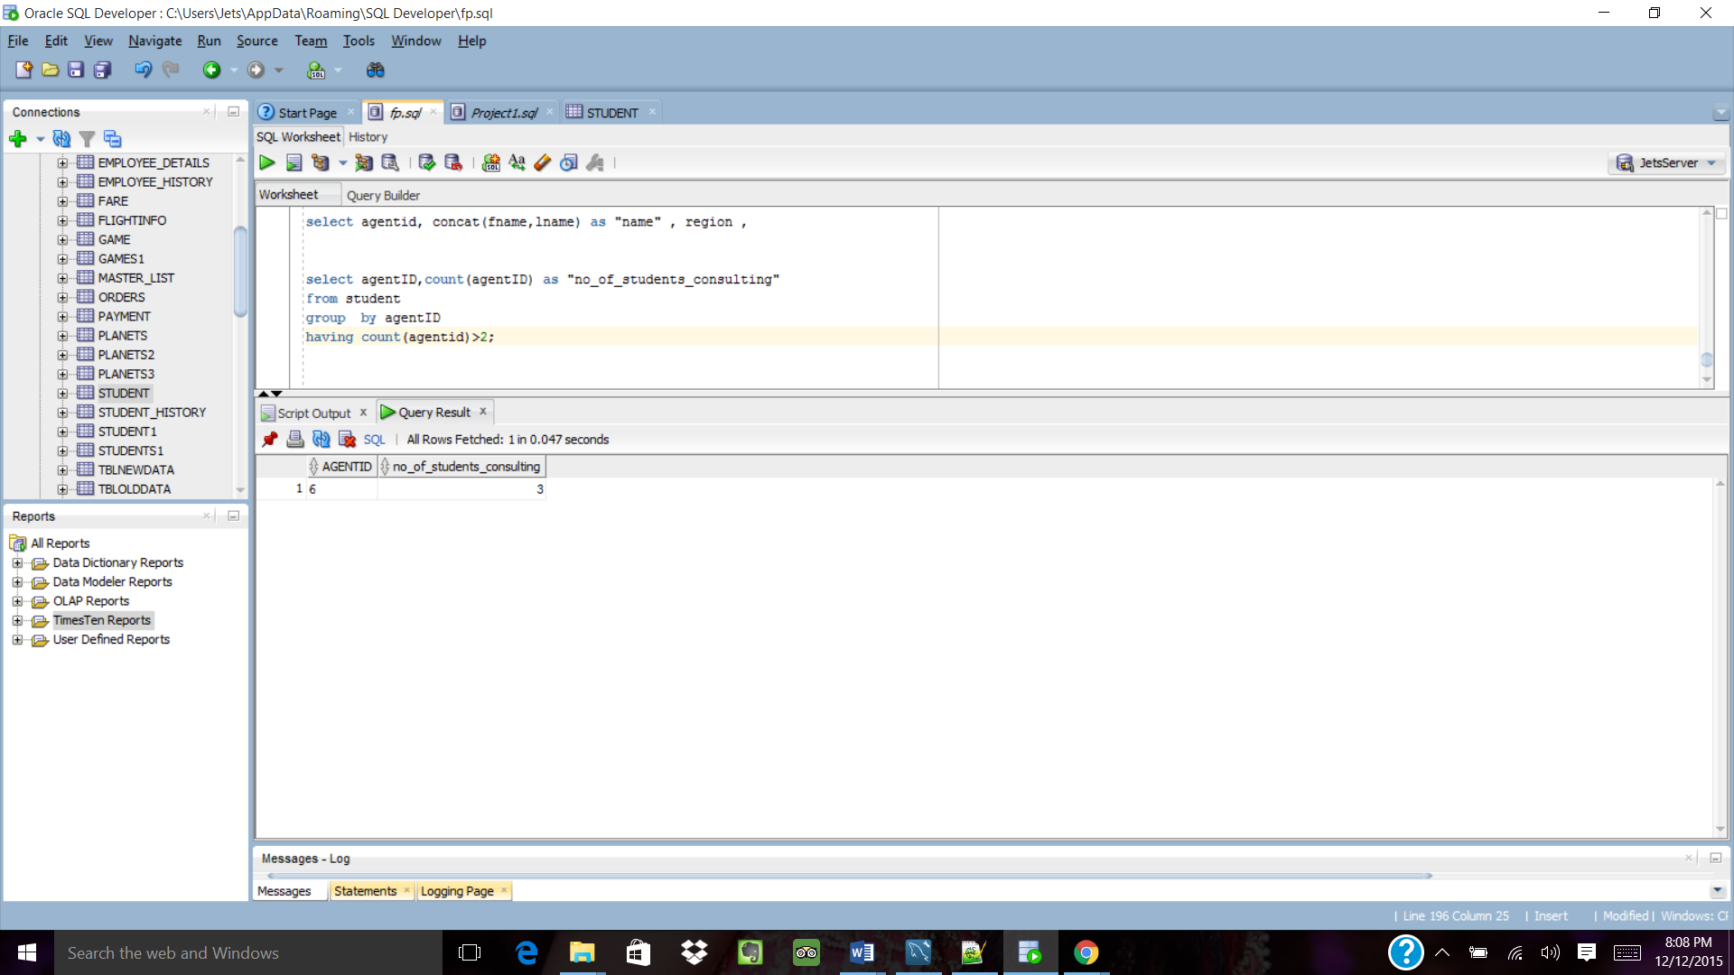

**5.**

SELECT GamesID

FROM consultingfee

WHERE ROWNUM <= 2;

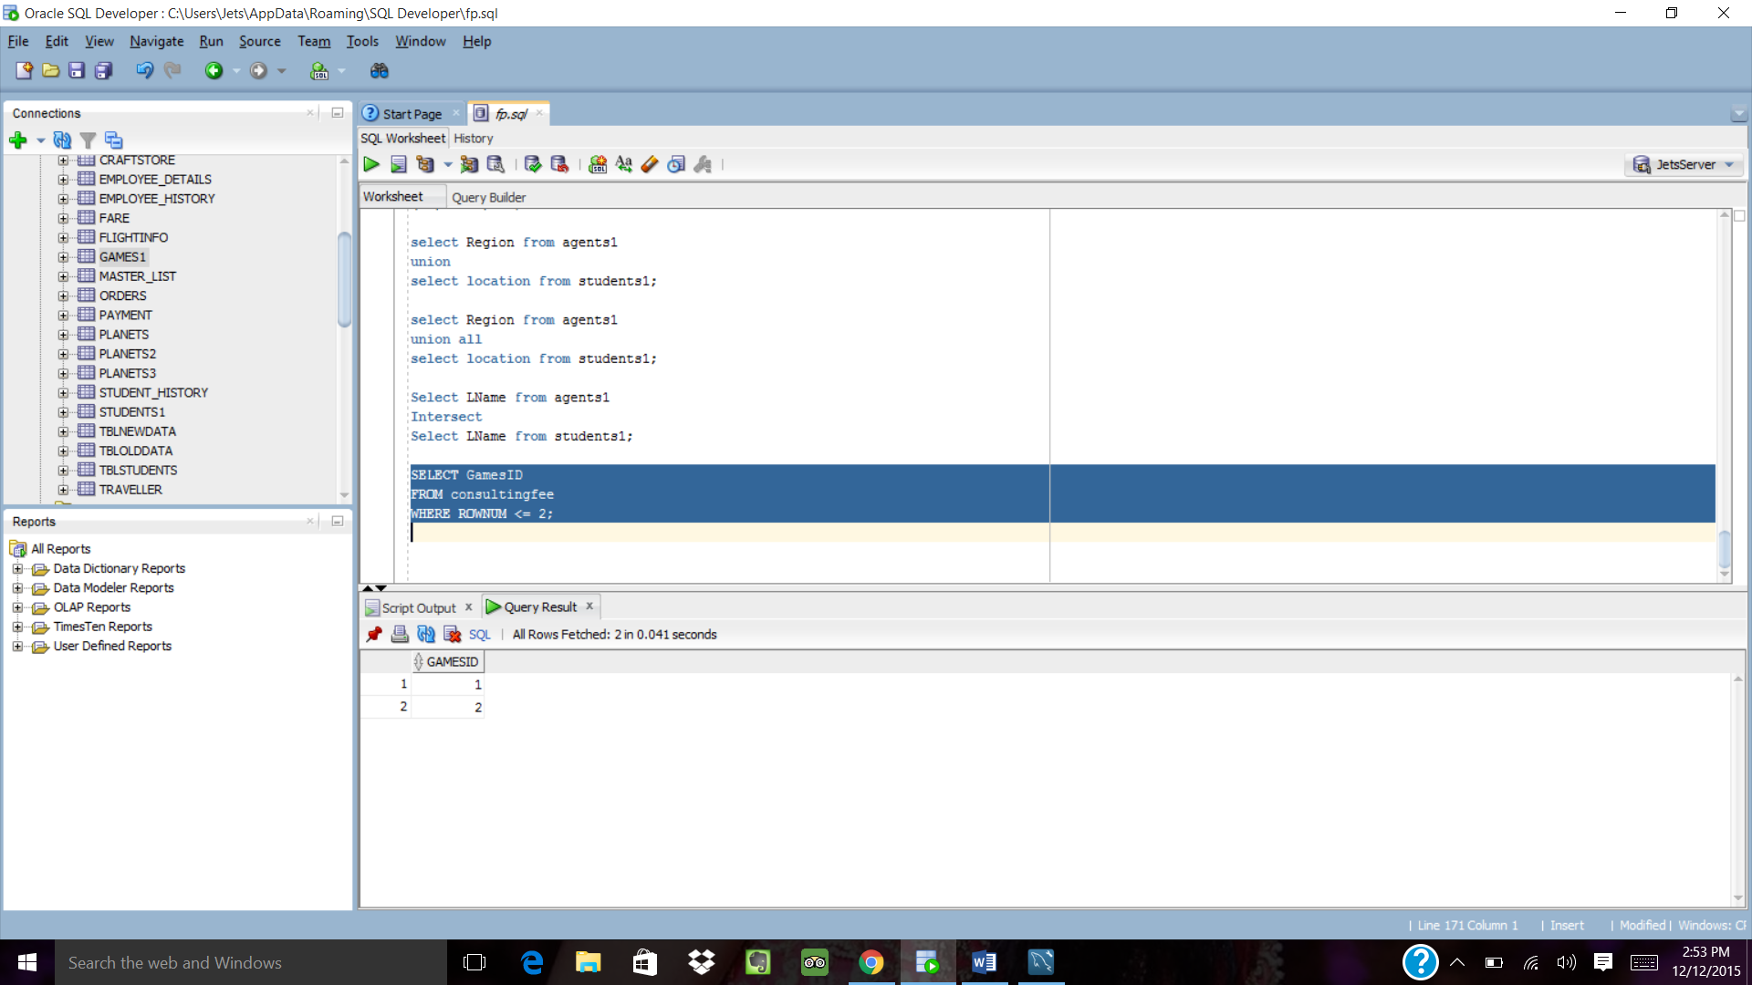

**6.**

select * FROM (SELECT agentID, region ,years FROM Agents)

PIVOT (SUM(years)

FOR (region) IN

('A' AS "region A",'B' AS "region B",'C' as "region C"))

ORDER BY agentID;

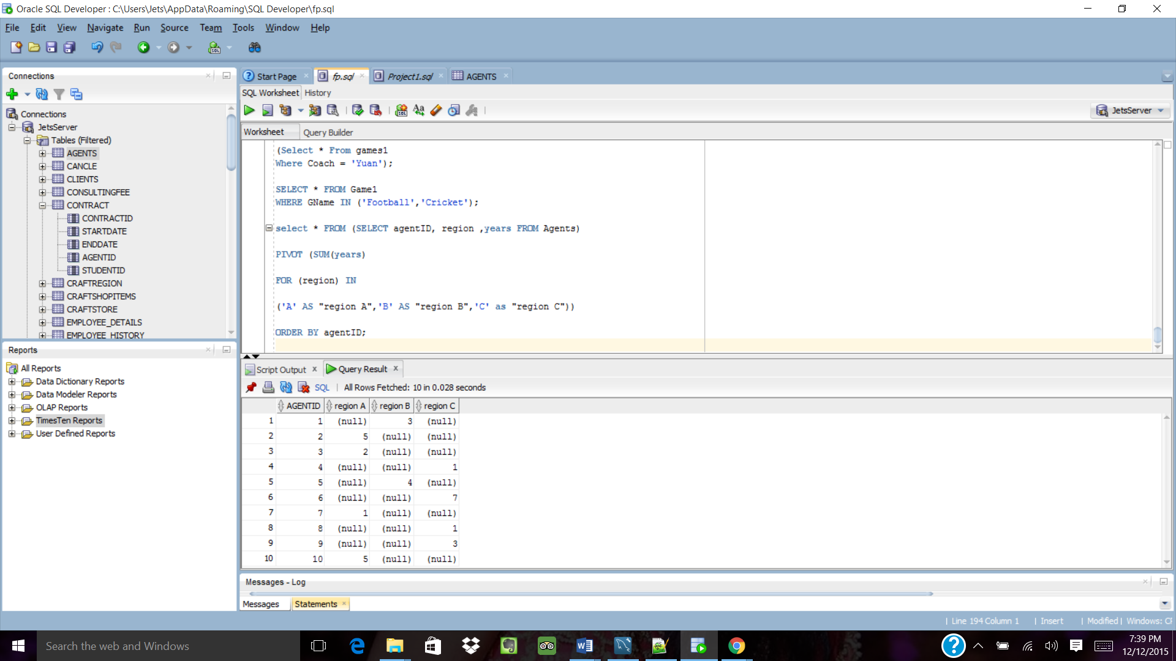

**7.**

select agentid as "ID" ,concat(fname,lname) as "agent",region

from agents

where MANAGER = 'Bose';

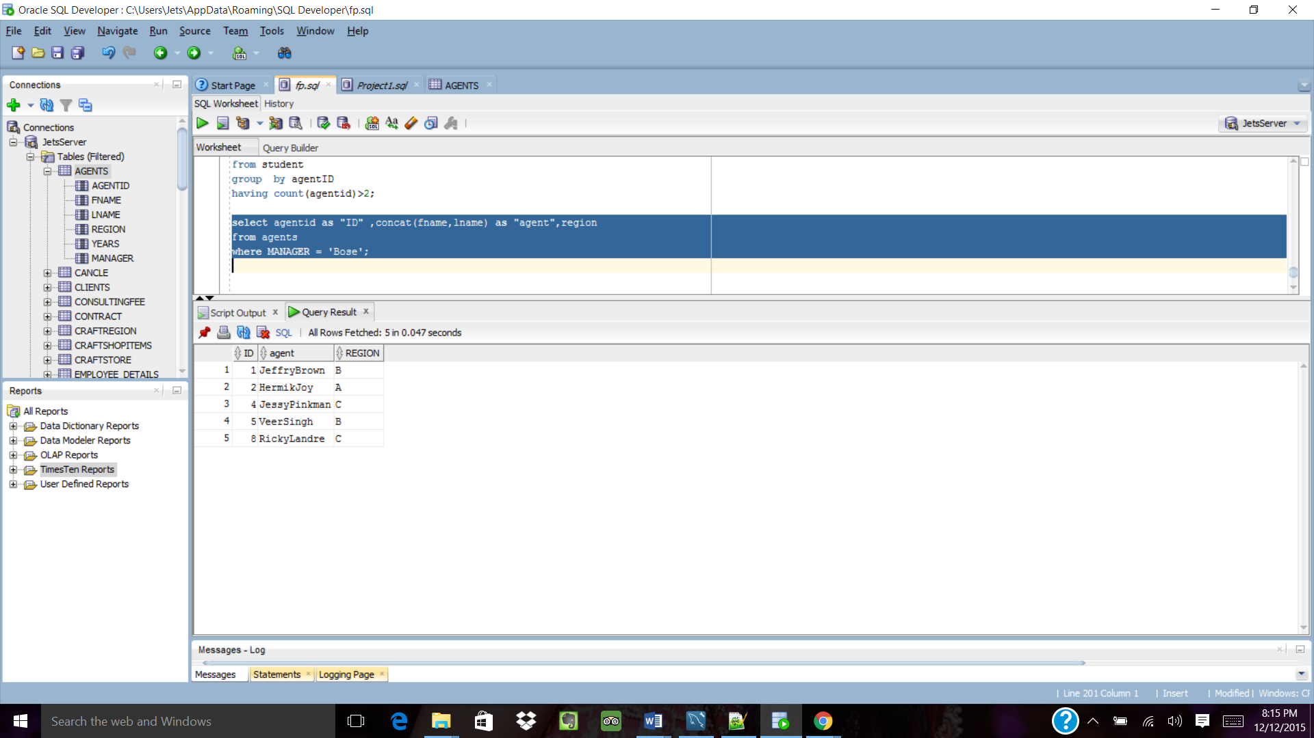

**8.**

Select Sum(Amount) From consultingfee

WHERE EXISTS

(Select * From games

Where Coach = ‘Yuan’);

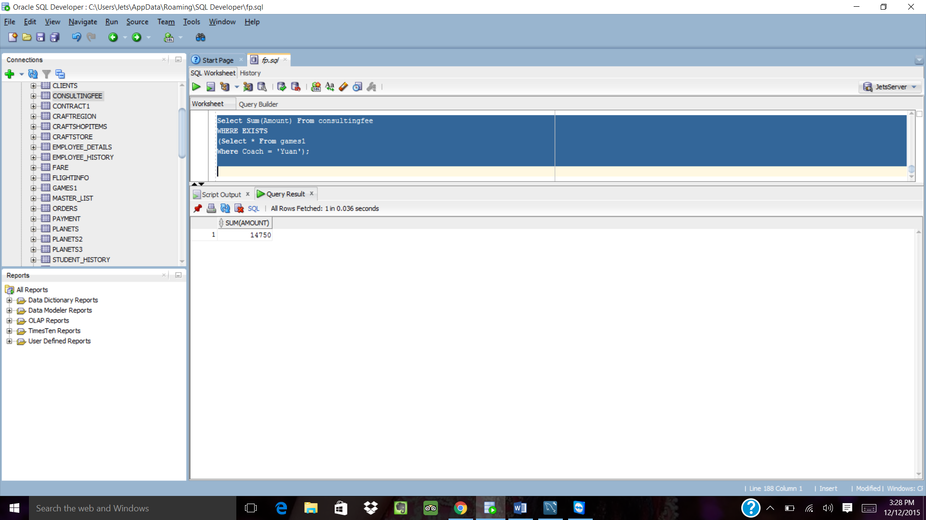

**9.**

select agentID,count(agentID) as "no_of_students_consulting"

from student

group by agentID

having count(agentid)>2;

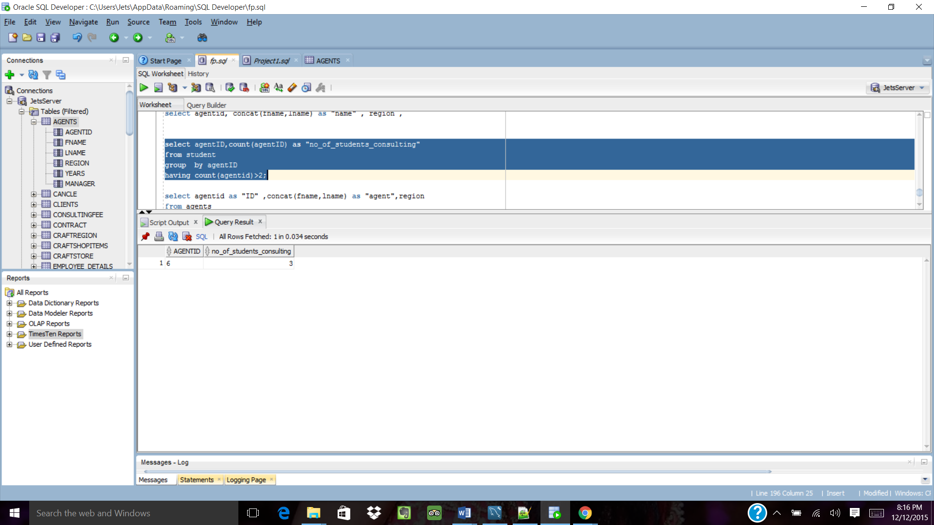

**10.**

select agentid,sum(amount)

from consultingfee

group by agentid;

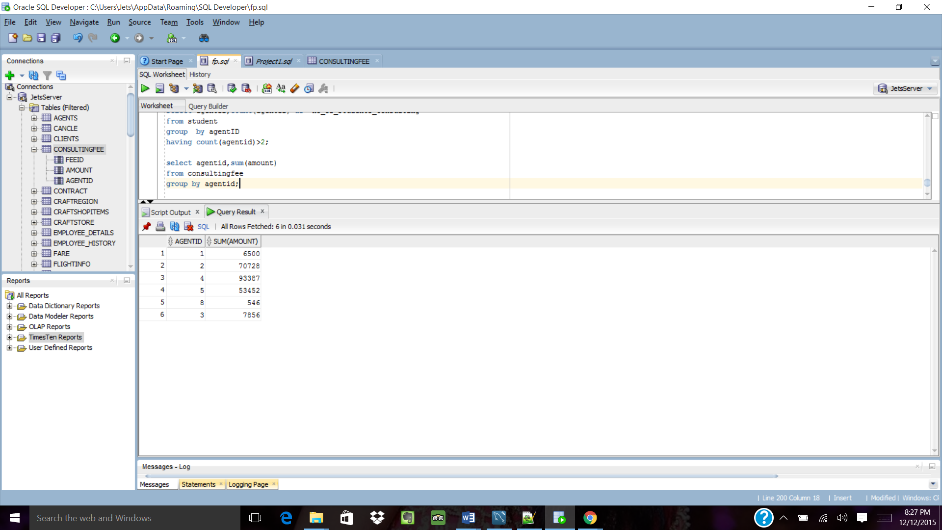

**Web Interface:**

Clybourn Sports Consulting Company WebPage.

Landing.html is the main page of the website.

On click event of all the five entities in the navigation bar, redirects to their particular webpage.

The Icons provided at the bottom of the webpage, on click event of those icons, their linked account are redirected.

On click event of “Back”, all the current webpage is redirected to the main landing.html page.

Main page:

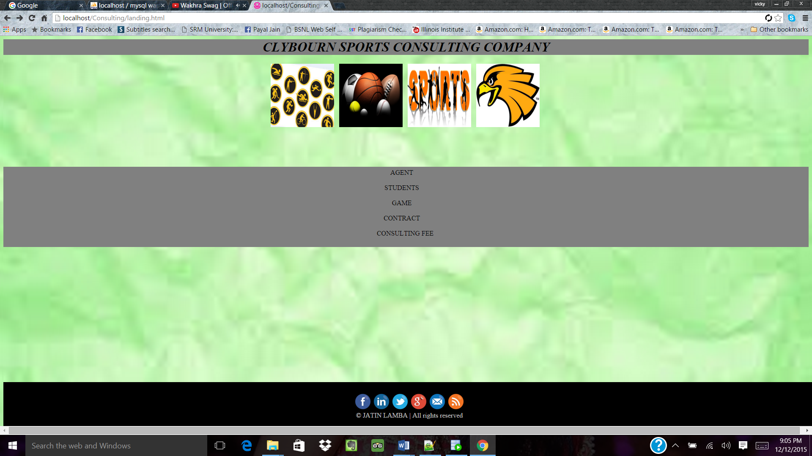

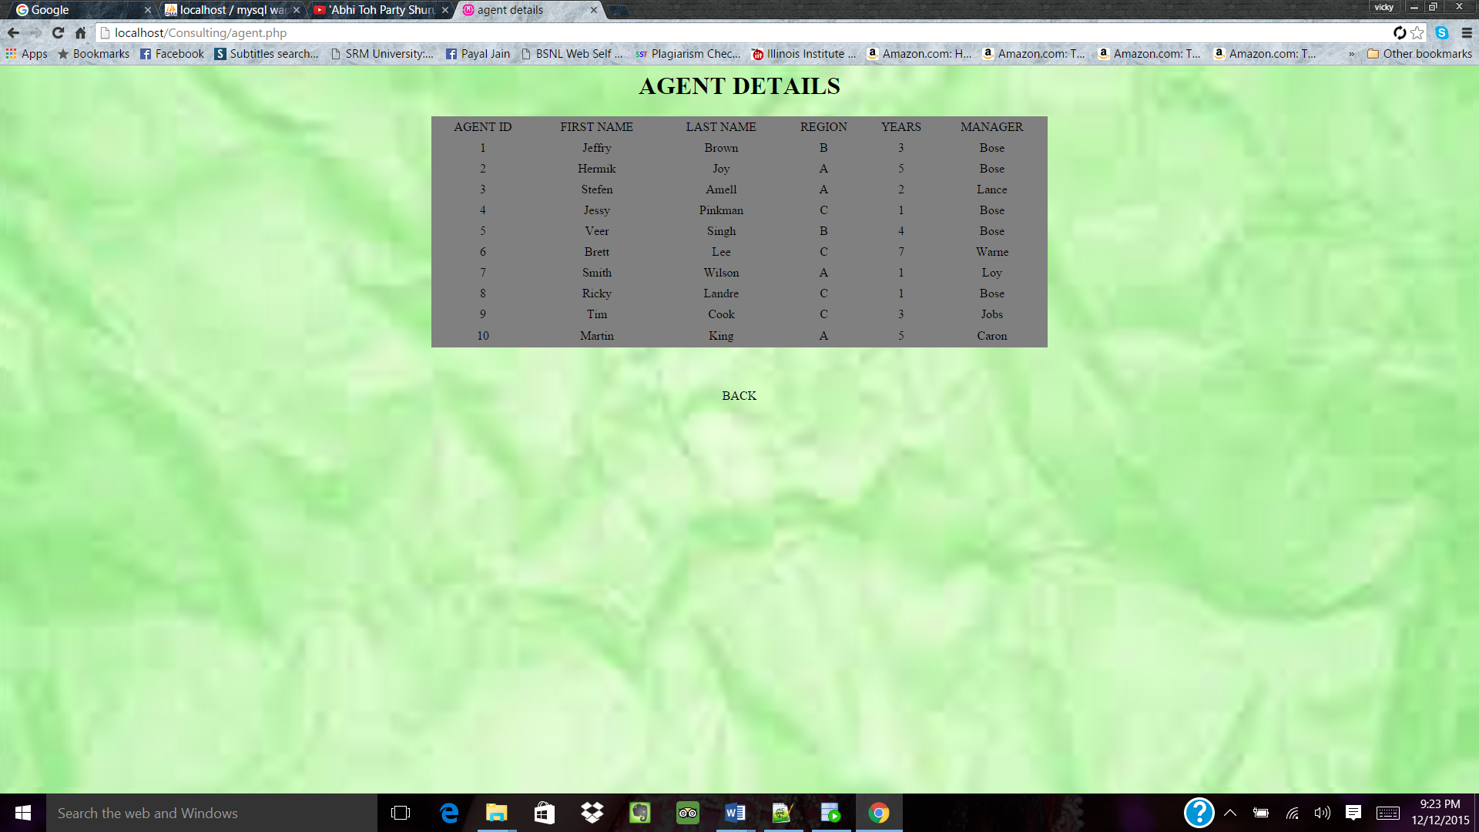

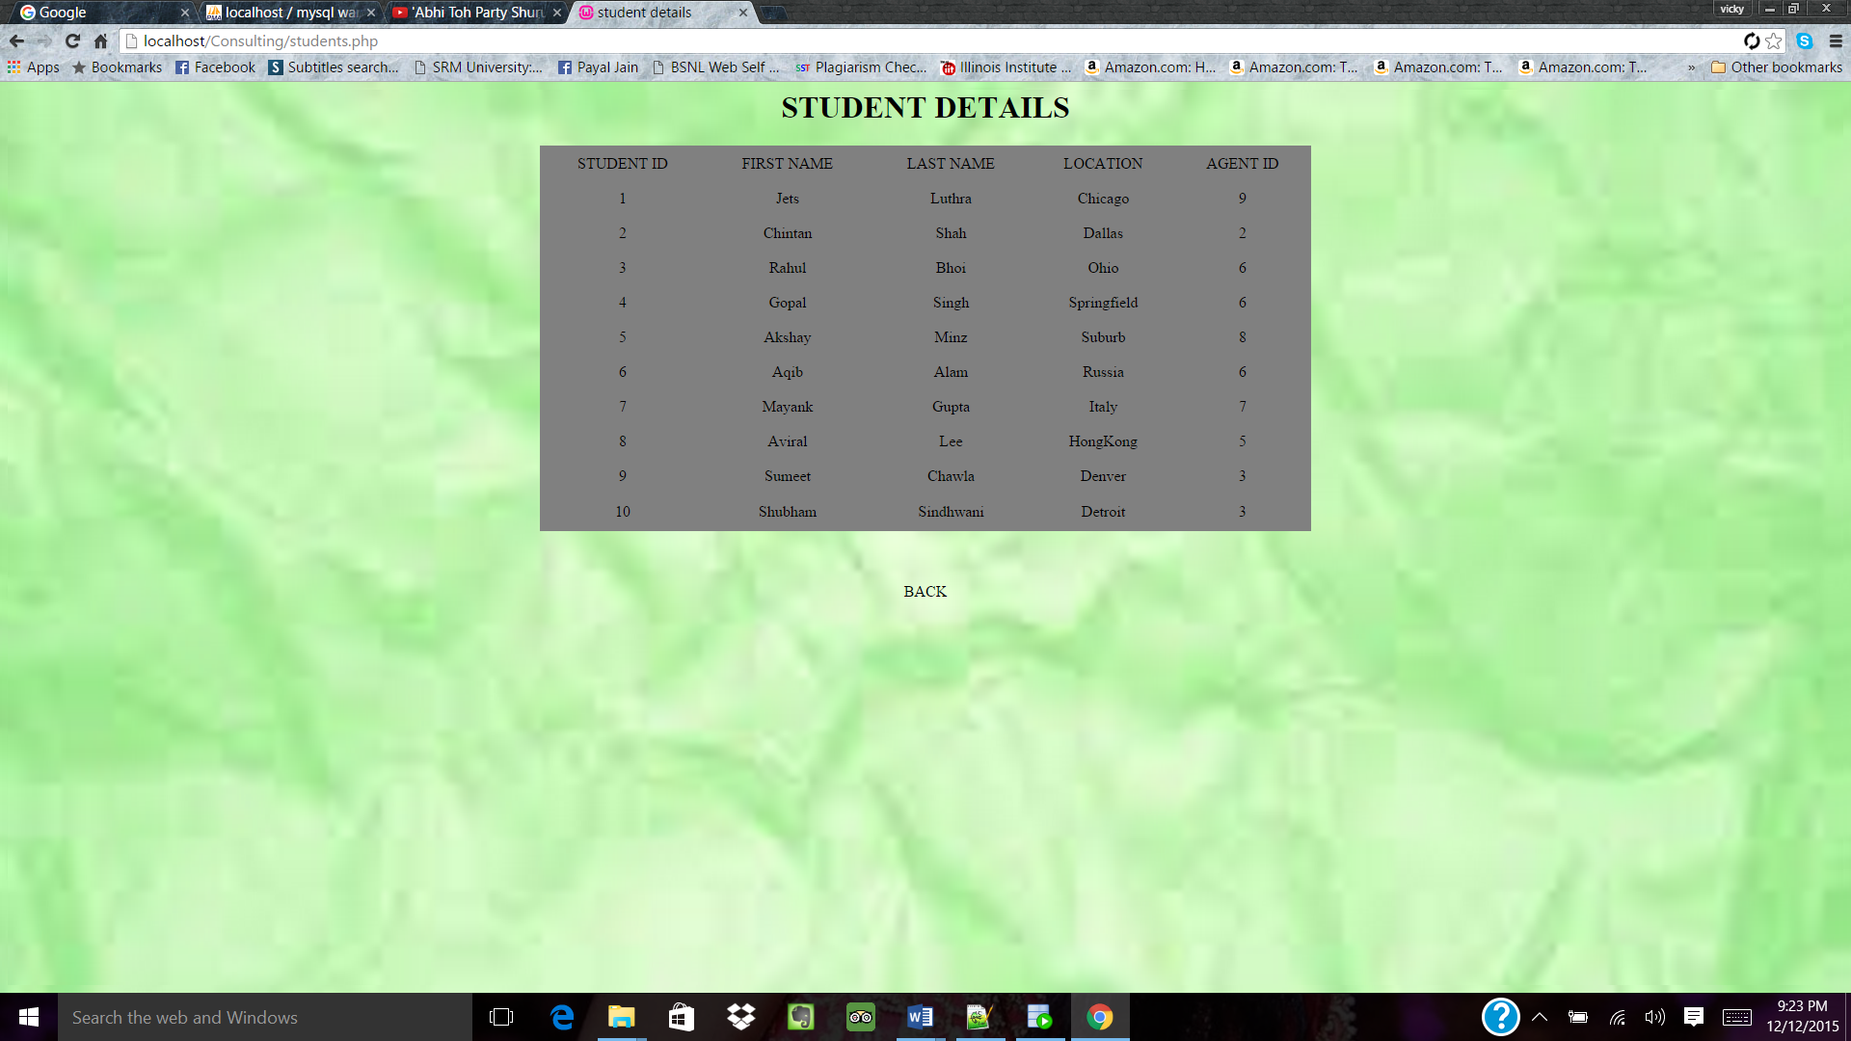

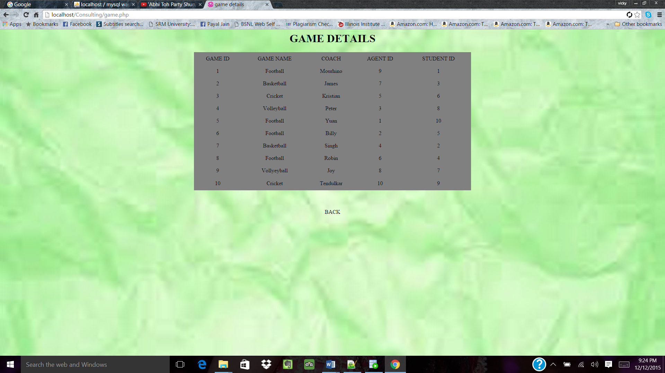

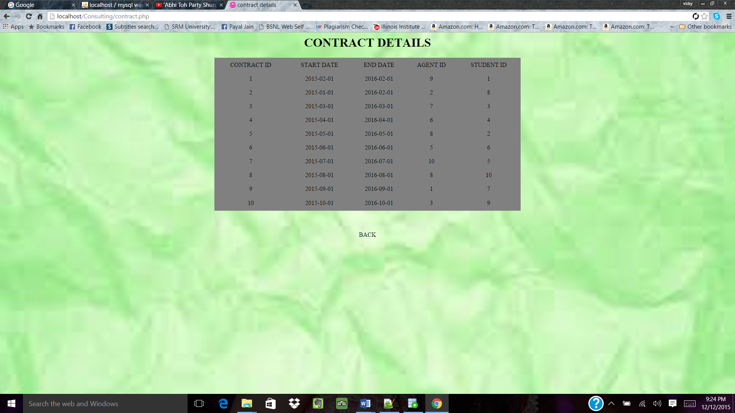

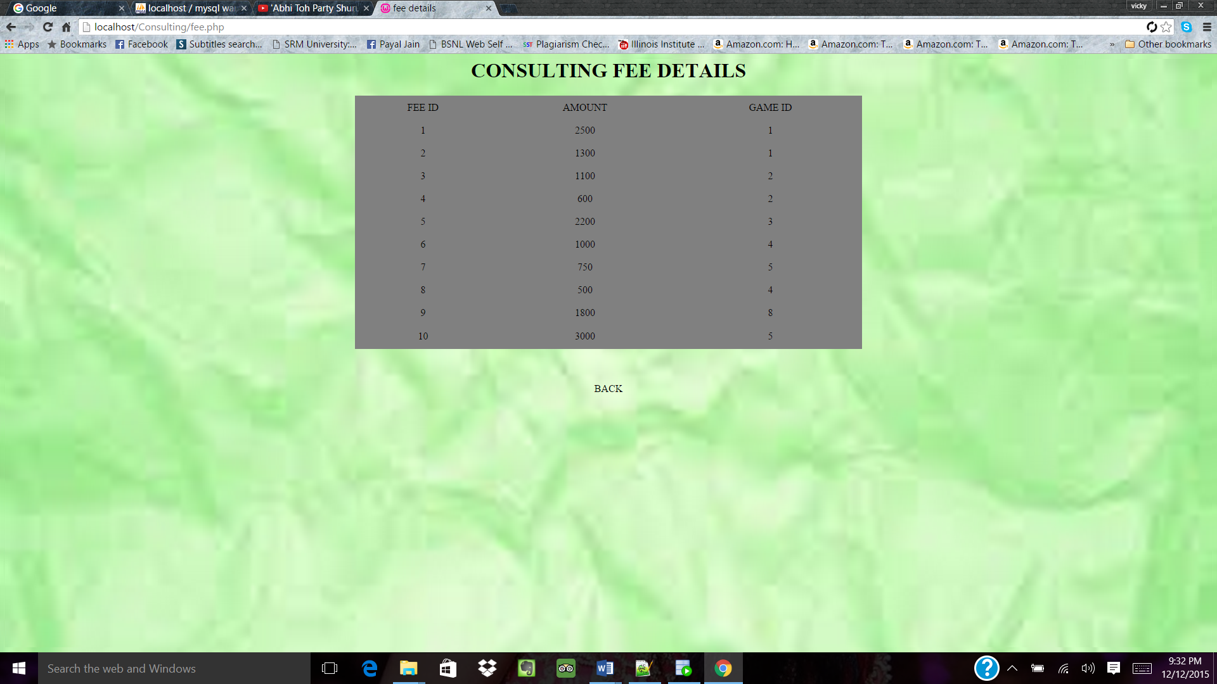

**Phase V**

**Reports:**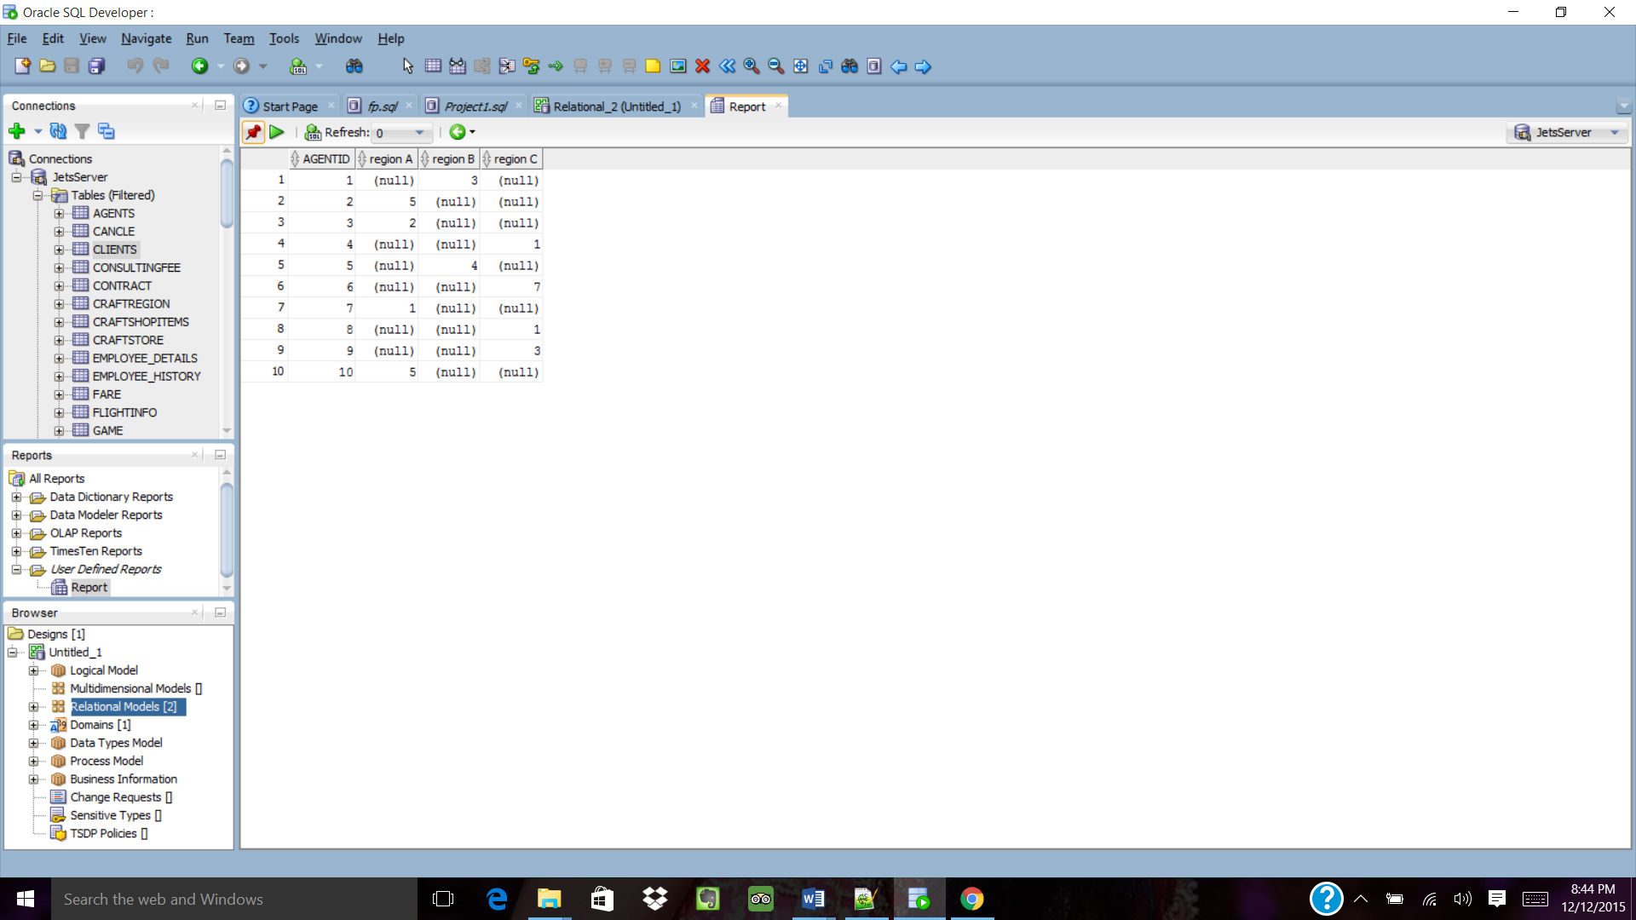

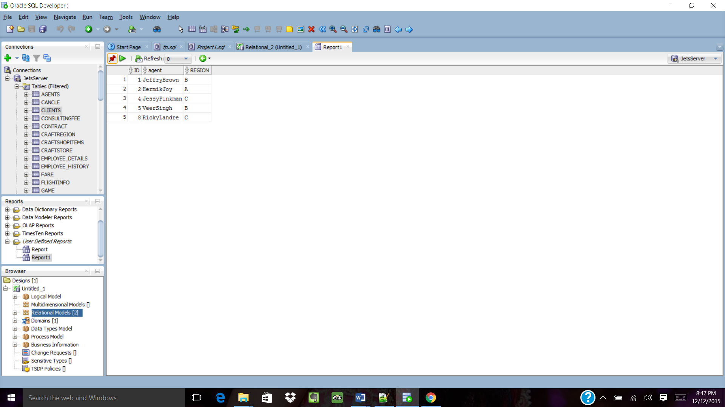

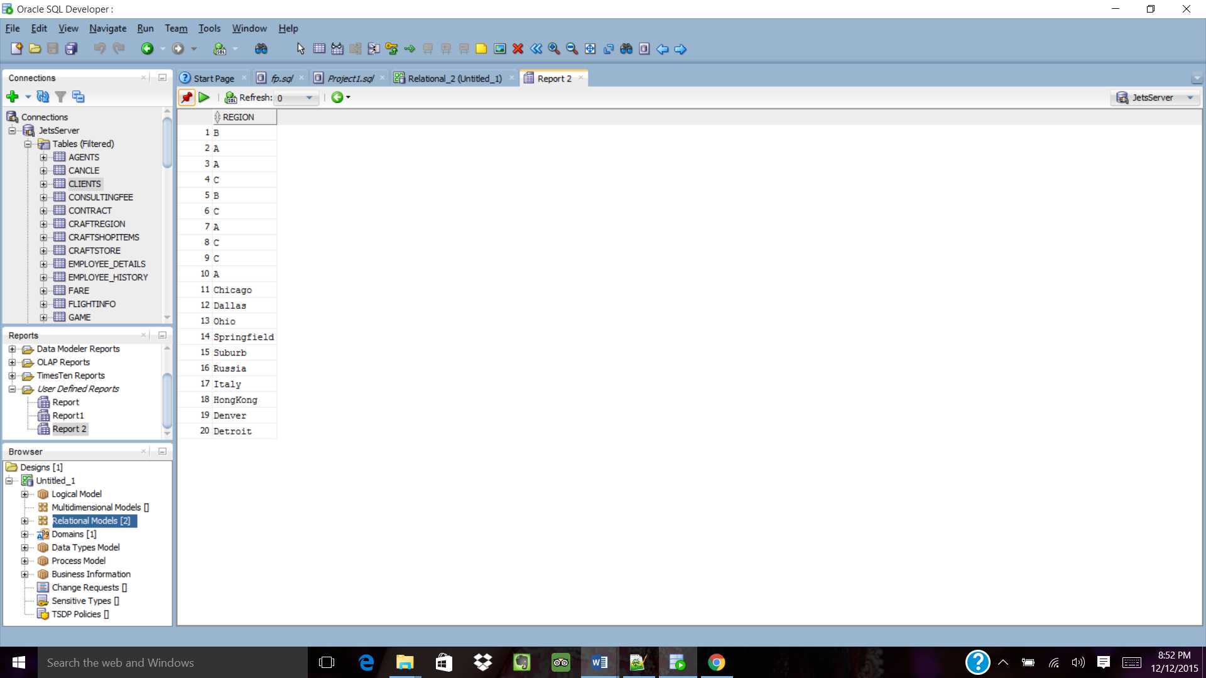

**Phase VI**

* **This database can be further improved by introducing new tables related to the services available to the students.**
* **Membership details can be stored in a table, for purpose of searching the records of a member related to their contract or services in an easier way.**
* **More functionalities can be added like giving discounts on various services to gain more clients for their company.**